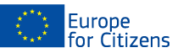

The project
«TWINNING=WINNING»
was funded with the support of the European Union under the Programme "Europe for Citizens"
Applicable to the Strand 2 – Measure 2.1 "Town-Twinning”

Participation: The project involved 171 citizens, notably 65 participants from the Uggiate-Trevano (Italy),
52 participants from Pakruojis (Lithuania), 19 participants from Põhja-Pärnumaa (Estonia), 35 participants from Rundāle Municipality (Latvia). Moreover, to extend the twinning network in Project activities participated new possible twinning towns – 6 participants from Ruaudin (France) and 5 participants from Adelsdorf (Germany). Also the EU level experience gained 3 participants from Swisloch (Belarussia).
Location/ Dates: The event took place in Rundāle (Rundāle Municipality), from 31.05.2018. to 03.06.2018.
Short description:

31.05.2018. Project Opening Event
Short description: The aim of the event was to get mutually introduced to participating municipalities, to present main objectives of the Project, activities and expected results. Each delegation held introductory speech about participation in the Project. All event long there was possibility to make contacts, to discuss twinning experience and expectations through EU dimension. Potential directions and spheres of further possible cooperation were discussed.

01.06.2018.
Short description: Live History Trip was realized with the main aim to present history of Latvia and Baltic states by guided trip to Garden of Destiny in Koknese thus increasing understanding about common history of Baltic states and its impact to citizens’ habits and way of thinking. Participants were discussing about ways to decrease Euroscepticism and to promote positive democracy praxis.
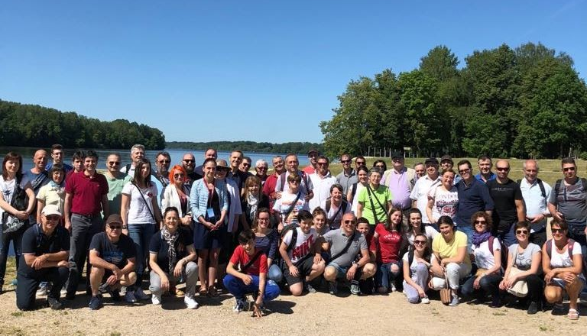
The day concluded in National culture evening “Welcome, Europe!”, participating local folk dance groups from Rundāle (LV), presenting Latvian national costumes as part of its nation strength symbols. Philharmonic band from Uggiate-Trevano (IT) “St.Cecilia” held concert which symbolically began with hymns of Italy and Latvia and concluded with hymn of Europe. Overall the event presented multiculturalism and multilingualism of Europe as common strength and unique value to be preserved and promoted.
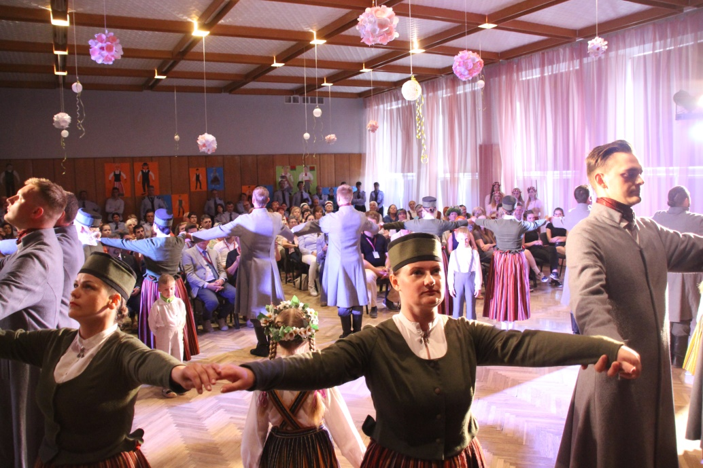

02.06.2018.
Short description: On 1st part of day of 02.05.2018. official delegations of all participating partnering municipalities – Rundāle (LV), Pakruojis (LT), Põhja-Pärnumaa (EE), Uggiate-Trevano (IT), Adelsdorf (DE), Ruaudin (FR), Swisloch (BY) participated international discussion: TWINNING=WINNING, highlighting existing experience of town twinning, presenting vary of twinning forms and sharing best existing praxis. New possible twinning events were discussed making basis for further cooperation. The discussion made excellent overview of diversity of twinning events and methods, as a way to foster citizens’ involvement in societal and democratic processes, thus decreasing the Euroscepticism and strengthening common sense of EU.
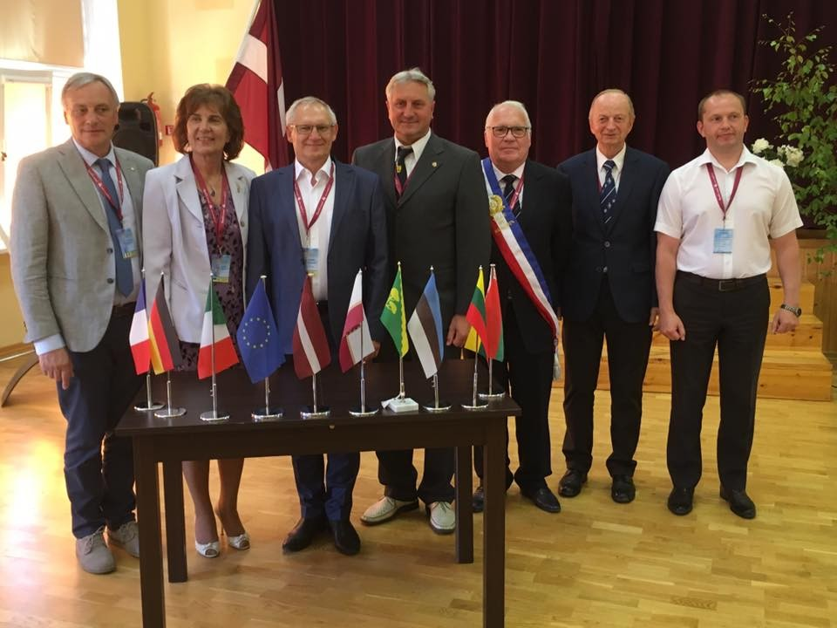
Meanwhile the representatives of Red-cross Italy Uggiate-Trevano committee had meeting with Red-cross Latvia Bauska committee sharing experience. Both participating parties found the meeting valuable.
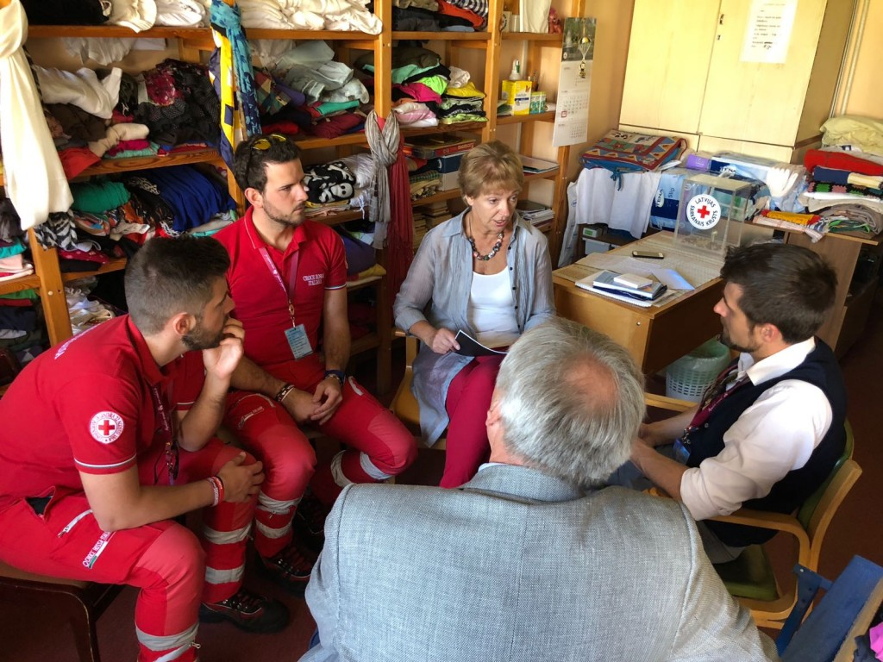
At the same time culture collectives – folk dance collectives “Reketys” from Pakruojis (LT), “Laieldes” from Põhja-Pärnumaa (EE) and “Rundāle”, “Šurpu turpu”, “Madaras” from Rundāle (LV) participated creative workshop “Hand in hand” in Rundāle Palace Garden in order to create common performance for Rundāle Festival Concert, thus symbolizing unity of Europe, richness of diversity and multilingualism as opportunity.

While the philharmonic band “St.Cecilia” from Uggiate-Trevano had performance in Bauska, presenting traditional culture values of project partner Uggiate-Trevano (IT) and their unique experience to wider public.
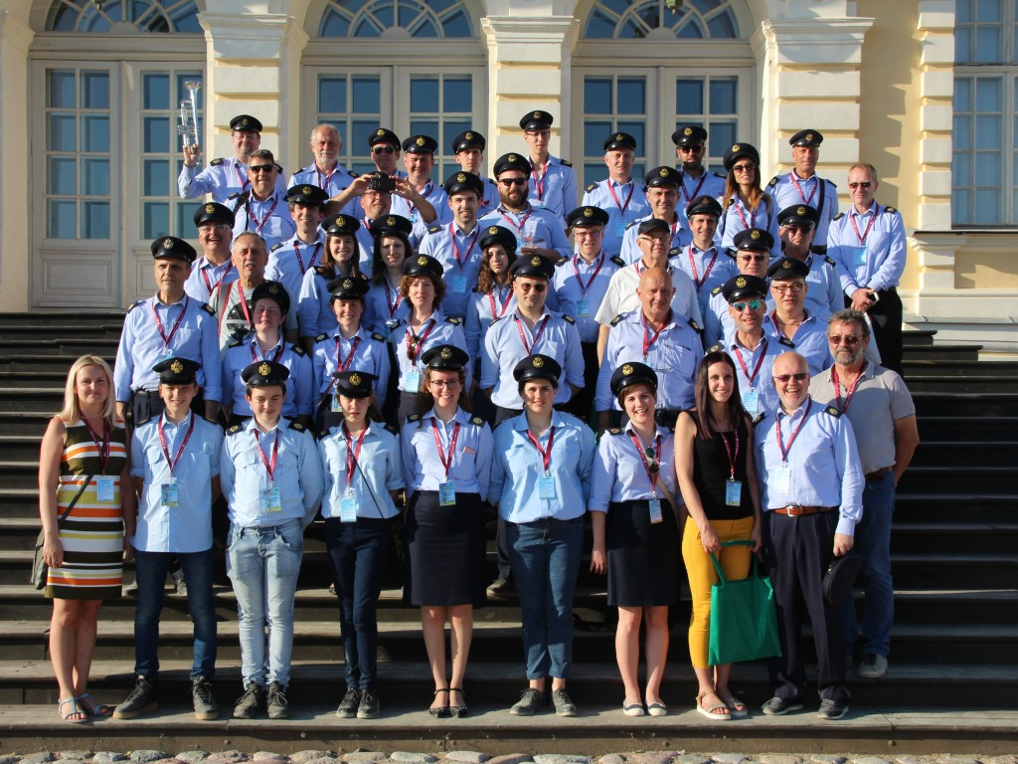

On 2nd part of day all the partners were participating Rundale Festival procession and concert, this year dedicated to centenary of Latvia. The musical accompaniment was ensured by philharmonic band “St.Cecilia” from Uggiate-Trevano. The Festival concert through folk dances of three Baltic States and national songs told the story about common roots of Baltic tribes. Totally 10 cultural collectives were participating common concept of Rundāle Festival, presenting cultural diversity, history and culture, facilitating mutual tolerance and solidarity.
The concert finalized with common performance of all participating culture collectives also from partnering municipalities, thus symbolizing the unity of Baltic States.
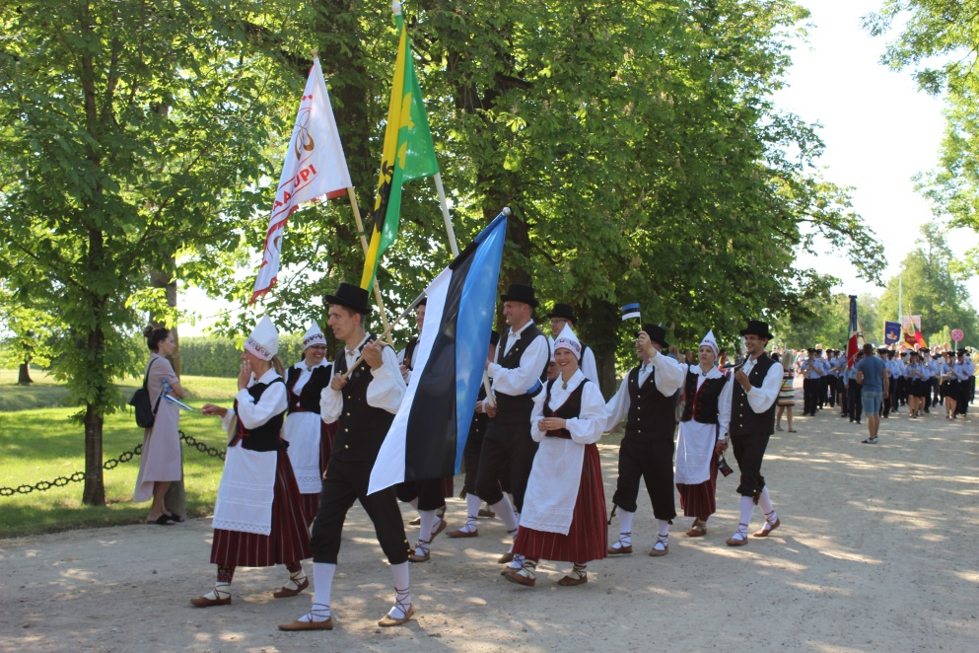

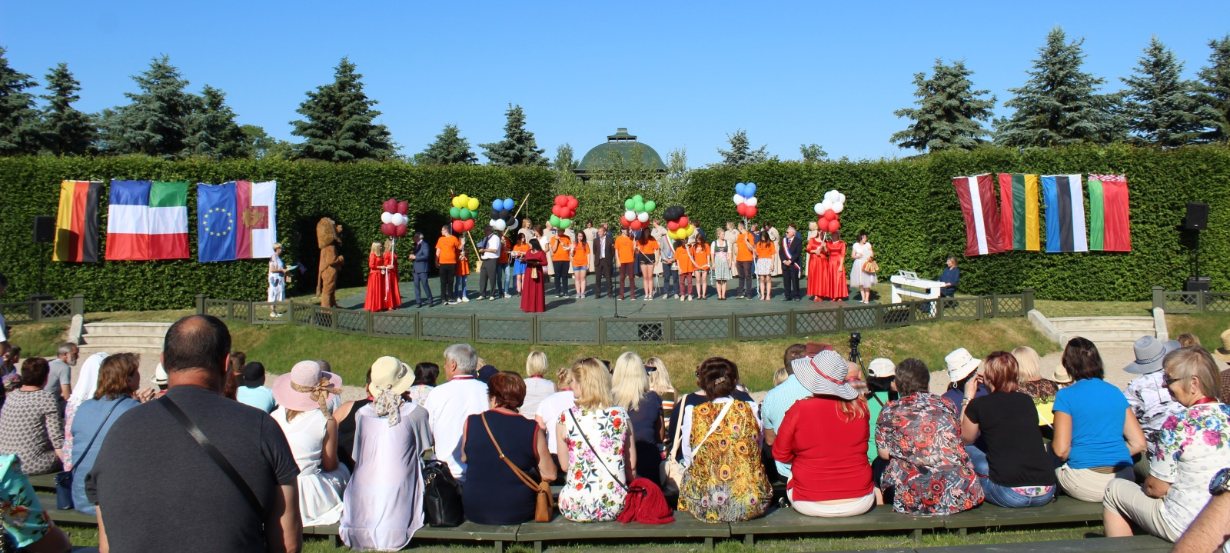

03.05.2018.
The last day of Project was dedicated to project closing event – summary discussion. Delegations evaluated the Project activities and reached goals, discussed the gained experience.
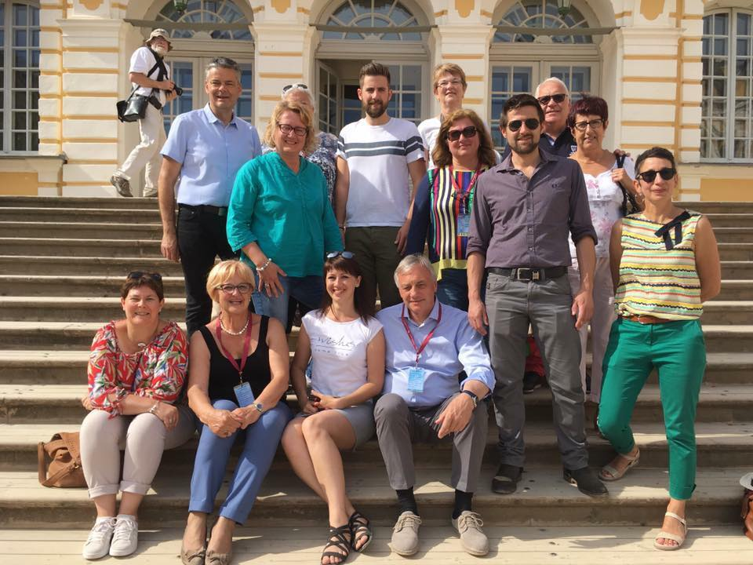

As a result of the implemented project new project ideas have formed. During the mutual discussions between representatives of partnering municipalities and participating twinning associations new stable basis for further cooperation has been founded. New possible cooperation intentions have formed with Ruaudin (FR) and Adelsdorf (DE) twinning associations in level citizens-meet-citizens. New further international project intentions have formed by Uggiate-Trevano (IT) twinning association and Põhja-Pärnumaa Municipality.
But what is more important, this is already 3rd twinning event where Rundale Municipality is participating and it is very obviously to track the changes in opinions about twinning experience – at the beginning the formal forms of twinning were acceptable, but now more and more local citizens have made connections to other towns’ citizens and it has become citizens-meet-citizens form.
Even more, the mutual cooperation between three dancing collectives – “RUNDĀLE” (Rundāle, LV), “LAIELDES” (Põhja-Pärnumaa, EE), “REKETYS” (Pakruojis, LT) was formed during the first Europe for Citizens project realised by Rundāle Municipality on 2015. Since then all three folk dancing collectives each year have cooperated in joint concerts (Halinga-EE, Rundāle-LV, Uggiate-Trevano-IT) and this cooperation have grown in friendship. Such kind of cooperation shows the great impact of small-scale cooperation projects presenting how formal cooperation transforms into friendship between citizens from different countries.
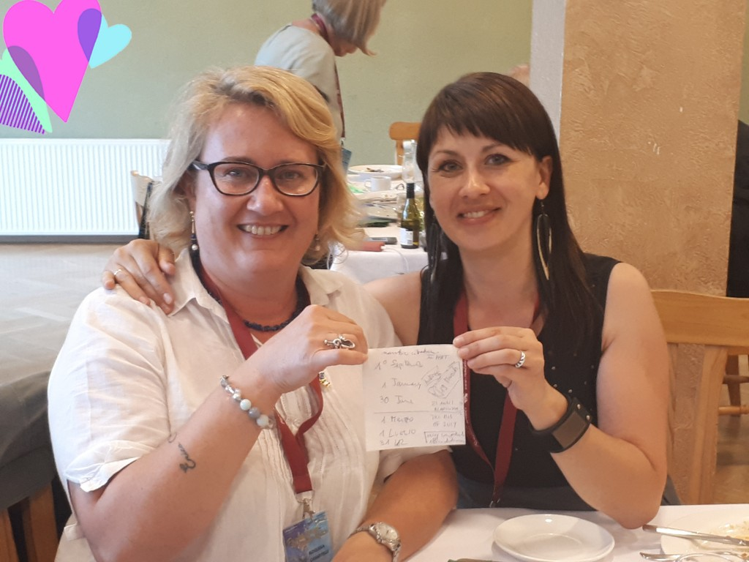

Before Administrative Territorial Reform - Halinga

